Directory:

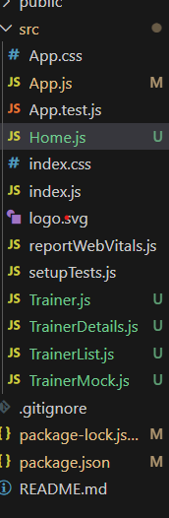

**Code for Trainer.js:**

class Trainer {

  constructor(TrainerId, Name, Email, Phone, Technology, Skills) {

    this.TrainerId = TrainerId;

    this.Name = Name;

    this.Email = Email;

    this.Phone = Phone;

    this.Technology = Technology;

    this.Skills = Skills;

  }

}

export default Trainer;

**Code for TrainerDetails.js:**

import React from "react";

import { useParams } from "react-router-dom";

import trainers from "./TrainerMock";

function TrainerDetails() {

  const { id } = useParams();

  return (

    <div>

      <h2>{trainer.Name}</h2>

      <p>Email: {trainer.Email}</p>

      <p>Phone: {trainer.Phone}</p>

      <p>Technology: {trainer.Technology}</p>

      <p>Skills: {trainer.Skills.join(", ")}</p>

    </div>

  );

}

export default TrainerDetails;

**Code for TrainerList.js:**

import React from "react";

import { Link } from "react-router-dom";

function TrainerList({ trainers }) {

  return (

    <div>

      <h2>Trainers List</h2>

      <ul>

        {trainers.map((trainer) => (

          <li key={trainer.TrainerId}>

            <Link to={`/trainer/${trainer.TrainerId}`}>{trainer.Name}</Link>

          </li>

        ))}

      </ul>

    </div>

  );

}

export default TrainerList;

**Code for TrainerMock.js:**

import Trainer from './Trainer';

const trainers = [

  new Trainer(1, "Shreya G", "shreya@example.com", "9876543210", "React", ["JSX", "Hooks", "Routing"]),

  new Trainer(2, "Aman K", "aman@example.com", "9123456780", "Angular", ["Components", "RxJS"]),

  new Trainer(3, "Riya R", "riya@example.com", "9999999999", "Vue", ["Directives", "Vuex"]),

];

export default trainers;

**Code for App.js:**

import React from "react";

import { BrowserRouter as Router, Routes, Route } from "react-router-dom";

import Home from "./Home";

import TrainerList from "./TrainerList";

import TrainerDetails from "./TrainerDetails";

import trainers from "./TrainerMock";

function App() {

  return (

    <Router>

      <Routes>

        <Route path="/" element={<Home />} />

        <Route path="/trainers" element={<TrainerList trainers={trainers} />} />

        <Route path="/trainer/:id" element={<TrainerDetails />} />

      </Routes>

    </Router>

  );

}

export default App;

**Code for Home.js:**

import React from "react";

import { Link } from "react-router-dom";

function Home() {

  return (

    <div>

      <h1>My Academy Trainers App</h1>

      <Link to="/">Home</Link> | <Link to="/trainers">Show Trainers</Link>

      <h2>Welcome to My Academy trainers page</h2>

    </div>

  );

}

export default Home;

**Ouput:**

